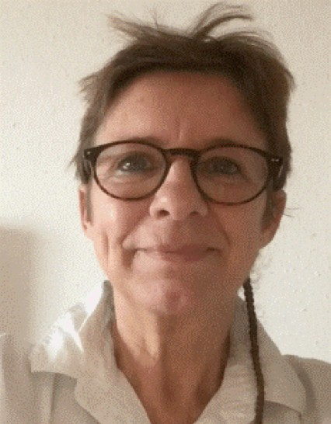

Florence GRANDO-RENON China, available immediately Website : florence-renon.com Phone No: 15071083712
Mobile sur toute la
We Chat: florence
Email: memepasmal@neuf.fr

Teacher of French as a Second Language & Visual Arts

PROFESSIONAL EXPERIENCE

2016: Early childhood teacher (4-11 years old)
(European Foundation for Cambodian Children, Cambodia. Association recognized by UNICEF) Medium of instruction: French and English

Courses taught:
- Non language class - Visual Arts
- Painting, sketching, collage, etc.
- On various media: paper, wood, tables, walls, cycles, cars, etc.
- Play sessions on prevention (health and hygiene)
- How to wash your hands and clean your teeth

2004-2009: Instructor (general public and medical staff)
Types of assignments: teaching, audits, presentations at international congresses, drafting of protocol datasheets, creation of a network of staff resources involving all hospitals in Paris

1982-2016: Nursing officer (Emergency room, neurosurgery, intensive care, psychiatry, maternity, etc.) Skills acquired: team management, complete focus, fast responsiveness, crisis management, empathy, patience, listening

QUALIFICATIONS

Post-Graduate Diploma in French Language Instruction (Université Sorbonne Nouvelle- Paris III)

Medical University Diploma in Pain (Medical faculty of Lariboisière-Jussieu Paris)

State Diploma in Nursing

OTHER COMPETENCIES
Linguistic abilities: English: Reading, Speaking, Writing (B1 level)

Mandarin Chinese: Beginner Level A1
(1 semester at Sorbonne University)

Visual Artist:
Drawings, paintings, collage and artistic recycling of papers. Several solo exhibitions.

REFERENCES

Professor Alain SERRIE: https://fr.wikipedia.org/wiki/Alain_Serrie
Contact: http://hopital-lariboisiere.aphp.fr/plus-de-details-sur-les-services-de-soins/medecine-de-la-douleur-medecine-palliative- lariboisiere/
Phone No: 01 49 95 81 70

Professor Didier Payen de la Garanderie: https://lemedecin.fr/paris0/hu-saint-louis-site-lariboisiere-aphp/anesthesiste/docteur- payen-de-la-garanderie-didier/51b6855e0418e47cfbc7854e50bbddbc/pro/{ut5
Phone No: 01 49 95 65 65

